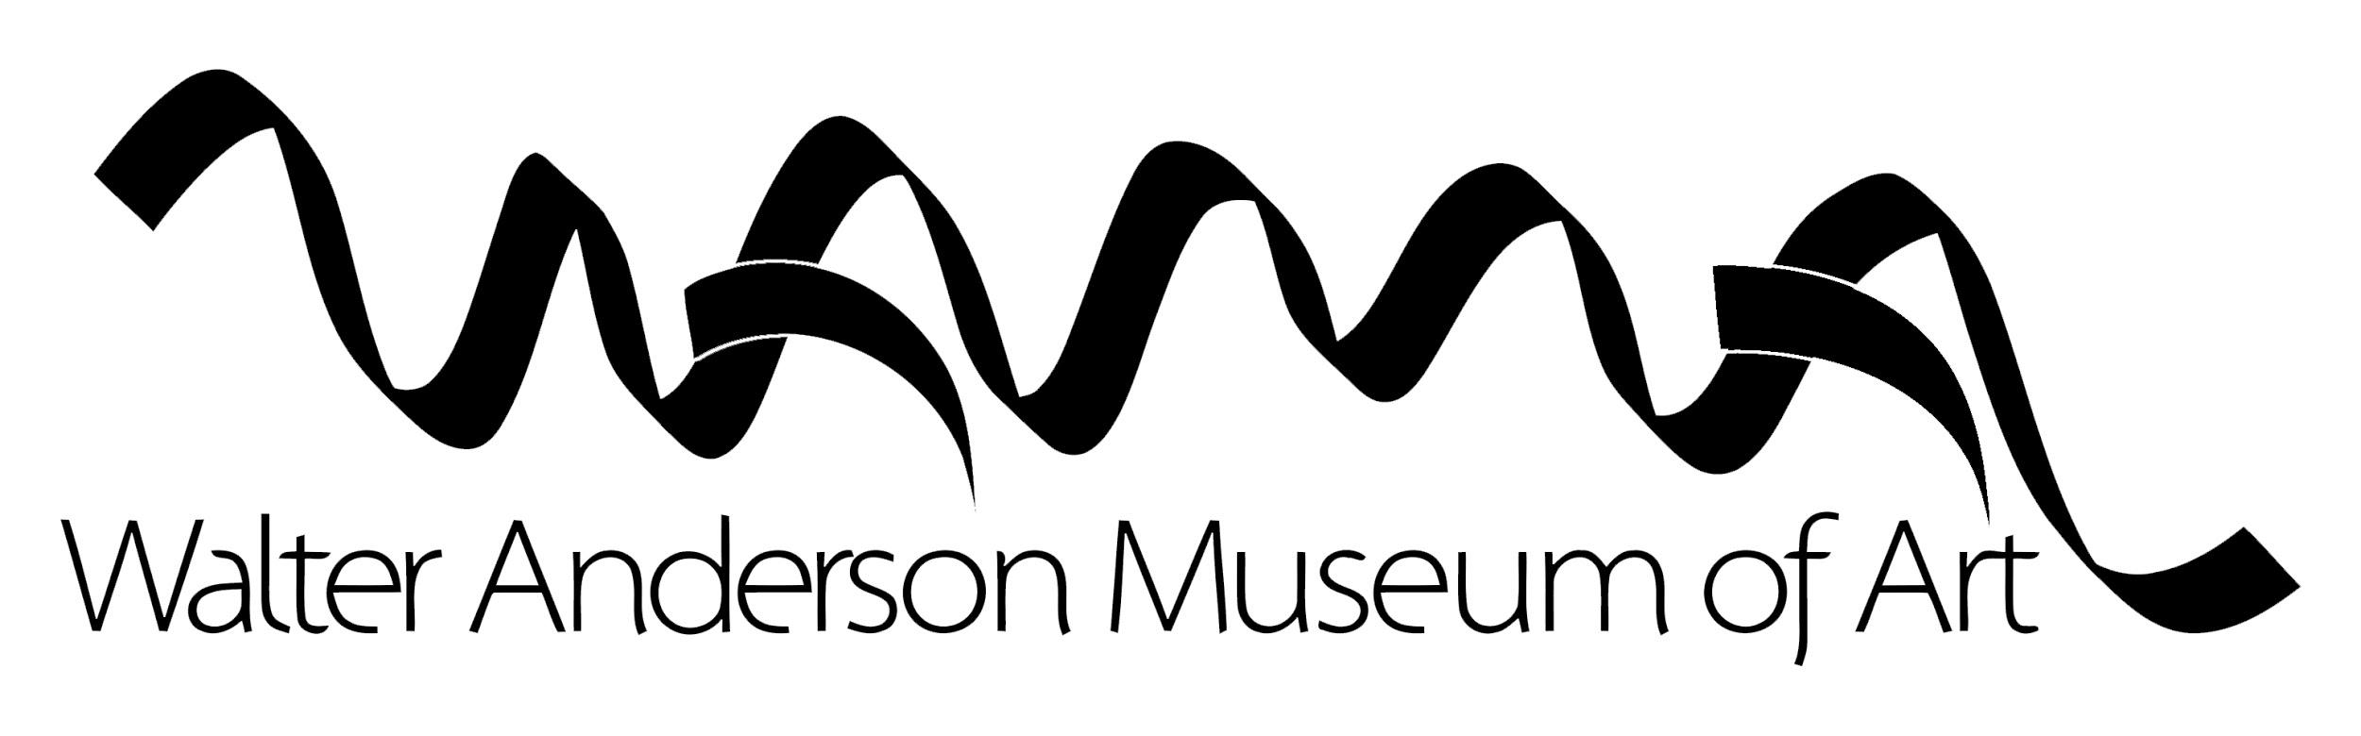

Children’s Art Show Submission Form
Please attach this to the back of the artwork.

Title of Artwork________________________________________________
Medium__________________

First and Last Name ____________________________________ Age_____
Grade_______________________________

School Name (If Homeschooled notate that here)
________________________________________________________________
Teacher’s Name
________________________________________________________________

Phone (____)_____-________ E-mail_______________________________
Submissions Accepted: 10am March 23 to 5pm March 27, 2020
Pick-up Day: Saturday, May 11 from 10-4PM
For any special arrangements please contact Tony DiFatta at educate@walterandersonmuseum.org.

-------------------------------------------------------------------------------------------------------------------------------------------------

