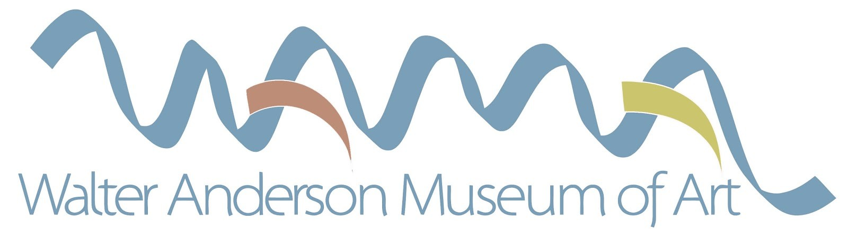

Dear Educator,

The Education Department of the Walter Anderson Museum of Art (WAMA) is pleased to again offer the annual Walter Anderson Museum of Art Scholarships to graduating high school seniors, supported by museum patron Linda Rosetti and private donations. Lifelong learning is an integral part of the Walter Anderson Museum’s mission and it is our desire to facilitate and encourage this process for generations to come. We request that you join us in this endeavor by encouraging your students to participate.

The WAMA scholarship seeks to uphold the following objectives:

• Provide financial assistance for students to continue their education
• Provide recognition for young aspiring artists
• Broaden awareness of Walter Inglis Anderson and his work.
• Promote WAMA throughout Mississippi and beyond

Scholarships will be awarded during the exhibition reception on April 23, 2020 at 2:00. All entries must remain on display until April 30, 2020. This will be a very exciting time for the honored senior students intending to pursue further education. Upon registration at the school of their choice, scholarships for winning students will be paid directly to those institutions.

Each school submits an original piece of artwork from a maximum of five students per school; one entry per student. Entries may be in any medium. All entries should be accompanied by a one page, double-spaced, typed statement regarding the piece and its connection to Walter Anderson‘s legacy or philosophies (he famously wrote that, “In order to realize the beauty of humanity, we must realize our connection to nature). Students are encouraged to visit the Walter Anderson Museum of Art and view the artwork of Ocean Springs’ beloved master muralist, painter, and sculptor. Information is available at www.walterandersonmuseum.org.

The Education Department of the Walter Anderson Museum of Art strongly encourages your school and students to participate, and thanks you in advance for your support. Attached you will find an application for the students; as-well-as additional information regarding submission deadlines, entry specifications, judging procedures, and awards. Please address all questions to Anthony DiFatta, WAMA Director of Education, at 228-369-3810, educate@walterandersonmuseum.org.

Sincerely,
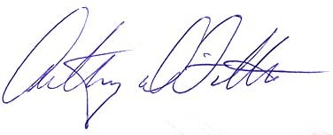
Anthony DiFatta, Director of Education, WAMA

